Purpose
This document gives you a solution to a Checksum Error during the Operating System (OS) upgrades to, and downgrades from, OS Ver. 1.14.03 of the ASC/3 controller. With the release of OS Ver. 1.14.03, new features were implemented that affect customers as listed below:
New features:
- Reduction in RAM footprint for reliable Aries compression and future ASC/3 application expansion
- FTP failed session and /set1 directory issues corrected for measure-of-effectiveness (MOE) collection
That affect:
- Aries customers who upgrade to ASC/3 NEMA application software Ver.2.55.00
- All ASC/3 customers in the next year (because of saving RAM footprint)
Note: If you run on 50 Hz, note that the information in this document is also for OS Ver. 2.14.03.
To resolve a checksum error and successfully install ASC/3 OS 1.14.03, you will install the OS two times.

Why install twice?

During an OS installation, files are removed within the existing OS of the controller. After the install, the files are restored onto the newly-updated OS.
For ASC/3 OS Ver. 1.14.03, its file structure is slightly smaller than previous versions of the OS. Because of this difference in file size, the controller sees this as an error as it runs through its CRC checks—and, when you reboot the controller after the first installation of the OS, you will see a checksum error screen.
To resolve this, you install the OS again. This installs the file structure of the OS on top of itself and enables the controller to now reference the file structure of 1.14.03 during the CRC checks. This way, you make sure the file sizes match with a successful OS install and make sure that the checksum error has been resolved.
The procedure that follows leads you through the full process to correctly install the OS via the ASC/3 Utility from
ASC/3 OS Ver. 1.12.06
to
ASC/3 OS Ver. 1.14.03.

Procedure to Correctly Install the OS
In the procedure that follows, make sure you go through each step carefully with a full understanding of what each step means. This will make sure you successfully install the OS.
- When you start the installation you see this warning pop-up.  - IMPORTANT: Do NOT power-off the controller during the install because this is a destructive process that could damage the controller.  - Click Yes to proceed. | 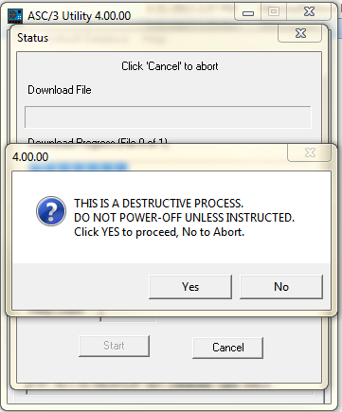

Note: The OS upgrade process temporarily removes the help files. You have the option to have the utility save and restore those files automatically after the upgrade is complete.  - Select what you want to do with the help files:  - To automatically save and restore the help files, click Yes.  - To remove the help files (to free up memory) or manually restore the help files after the upgrade, click No. |  |  | 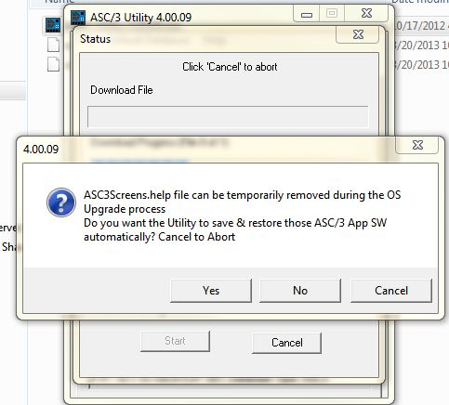
- After the 1st stage is complete, you must power-cycle the controller to start the flash update.  - IMPORTANT: Do NOT click OK to close this box until the controller has rebooted. |  | 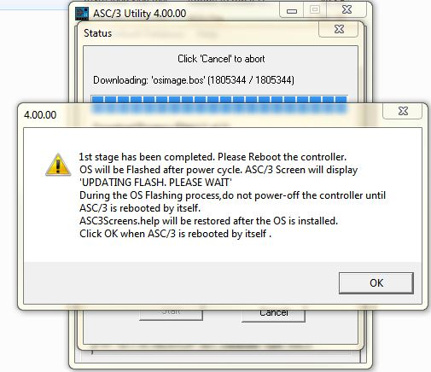
- IMPORTANT: If you have elected to automatically restore the help files after the install, you must power-cycle the controller again. If you were not to power-cycle the controller again, the help files would not be loaded onto the controller as shown  (the PART NUMBER and VERSION are blank): |  | 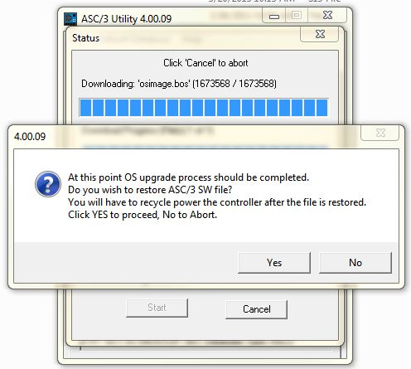
SOFTWARE MODULES
NAME PART NUMBER VERSION

BOOT 100-1047-212 01.14.03

APPLICATION 100-1082-254 02.54.00

CONFIGURATION 100-1049-001 N3000, 8

HELP

DEFINITIONS 100-1051-001 02.10.00

TEXT 100-1052-001 02.10.00

TELEMETRY 100-1032-501 V0.00.00

- As explained previously, you should now see a checksum error message, as shown to the right.
It is because of the difference in file sizes that you should expect this screen after the first installation.

Note: Depending on the previous OS installed on your controller, it is possible that you may not get this error message. If you don’t get this error message, your installation is complete; ignore Step 9.

FAILURE!!!!!

The controller has detected that the
ROM image checksum does not match
the internally stored checksum.

Stored checksum is B44E2440
Correct checksum is 3E93F7A0

Press ENTER to override

- Repeat Steps 1 thru 7 above and re-install ASC/3 OS Ver. 1.14.03.
Step 8 is not included because you should now expect to NOT see the checksum error.

